Computer Fundamentals Assignment – Questions 5 & 6

PORTFOLIO 2

Phil O’Donnell

2020-2021

**Portfolio Question 5: Login Credentials**

Here we had to create a login screen which gives the user 3 options; register, login or exit which I coded in 3 separate functions to use when called upon by the user. I introduced a new form of data validation to my coding to make sure the user inputs an integer, by setting the users input data type to ‘float’ then ensuring that it matched the integer equivalent.

I was quite satisfied with my code, apart from for when the user selects option 3, to exit where I wanted to ask the user if they were sure and if they typed anything other than ‘yes’ I wanted the program to return to the main menu, but I couldn’t figure out how to do it. I guess that it involved a return function or a function call within a function, so that’s where I need to improve upon next time.:

**Code:**

usernames=["bjamin", "jfiddle", "kberry", "podonnell511", "mmartinez1985", "lmod2017", "am1964",]

passwords=["bjamin1234", "jfiddle1234", "kberry1234", "podonnell5111234", "mmartinez19851234", "lmod20171234", "am19641234"]

def user_choice():

print("(1) Register")

print("(2) Login")

print("(3) Exit")

def user_register():

#once successful username and pw - prompt an account successfully created message and repeat user_choice function

new_name = input("Please enter the username you wish to use:").lower()# match the case of the list items

if new_name in usernames: #check if username already exists

print("Username already exists")

user_register()#ensures username is unique

else:

usernames.append(new_name)#username is unique can can be added to the list

new_pw = input("Please enter a password (minimum 8 characters)")

while(len(new_pw) < 8): # passord has to be 8 or more characters

new_pw = input("Invalid password. Please enter a password (minimum 8 characters)")

passwords.append(new_pw) # add valid password

print("Account successfully created!")

print("Welcome to Manage My Account")

def user_login():

user_name = input("Please enter your username:").lower() # convert to lower case to match password list case policy

if user_name in usernames: #searches for matching username in the list

user_pw = input("Please enter your password:").lower() # match the case of the list

if user_pw in passwords:

print("Welcome to Manage My Account")

else:

print("Sorry the password entered does not belong to the User Name provided")

user_login() ## i wasn't sure how to bypass the username request and just ask for the password

else:

print("Invalid Username")

user_login() #repeat until a matching username is entered

def user_exit():

print("Thank you for your visit - see you next time!")

exit()

user_choice()

choice = float(input("Please enter your selection from the menu above (1-3):"))

while(choice < 1 or choice > 3 or choice != int(choice)): # data validation including to ensure input is an integer

choice = float(input("Invalid Entry - Please enter your selection from the menu above (1-3):"))

if(choice == 1):

user_register()

elif(choice == 2):

user_login()

else: #choice == 3

user_exit()

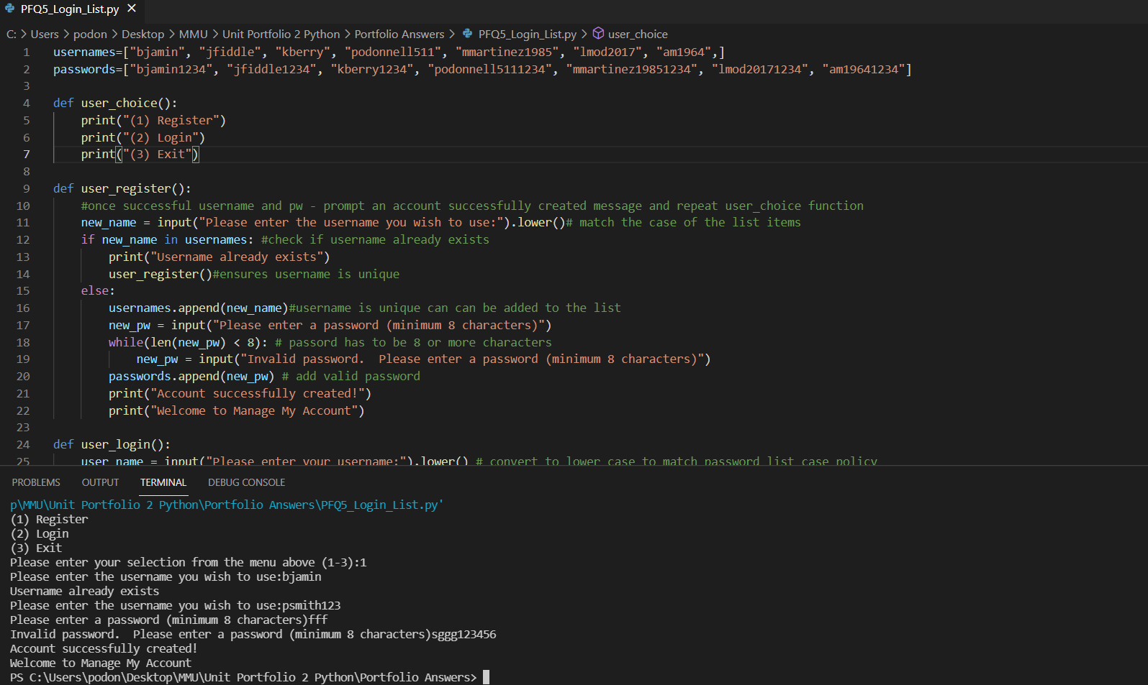

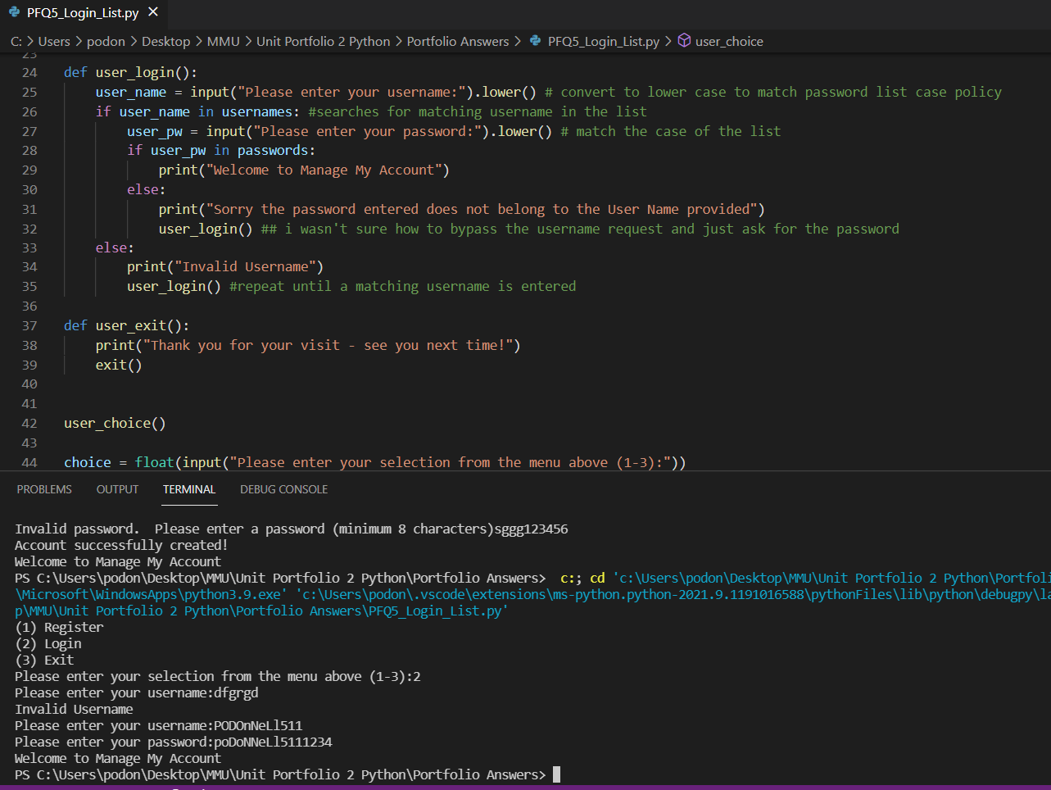

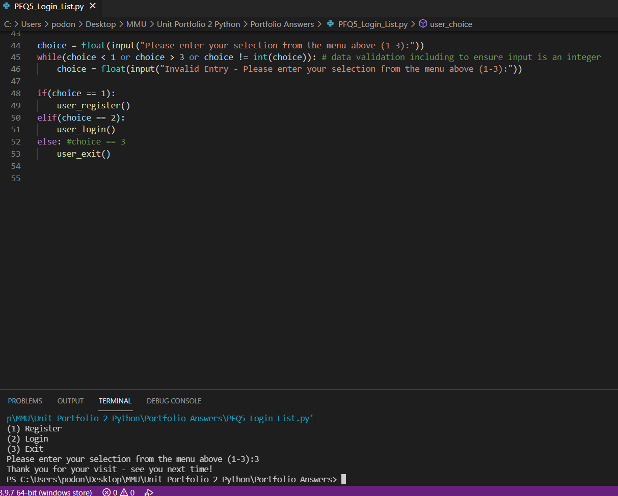

**Portfolio Question 6: First names File**

Here we created a new python file called Firstname_File and using python code, created a text file named firstName.txt, then coded to add 10 unique first names to the text file, before opening and reading the contents of the text file, then finishing by closing the file.

This is my first encounter with creating and manipulating text files using code, but I’m sure it won’t be my last! It seems reasonably straight forward and will get easier with practise.

Code:

#create a new file first_names.txt

firstNamesFile = open("firstName.txt", "x")

#write ten different first names to firstName.txt

firstNamesFile = open("firstName.txt", "a")

firstNamesFile.write("Sarah")

firstNamesFile.write("\nBen")

firstNamesFile.write("\nBrett")

firstNamesFile.write("\nJulio")

firstNamesFile.write("\nMariann")

firstNamesFile.write("\nMohammed")

firstNamesFile.write("\nLucas")

firstNamesFile.write("\nAnn")

firstNamesFile.write("\nDavid")

firstNamesFile.write("\nAndrew")

#open and read contents from firstName.txt

firstNamesFile = open("firstName.txt", "r")

print(firstNamesFile.read()) # it doesnt request we do this in the portfolio question, but I wanted to test it

#close the file

firstNamesFile.close() # always best to close the file

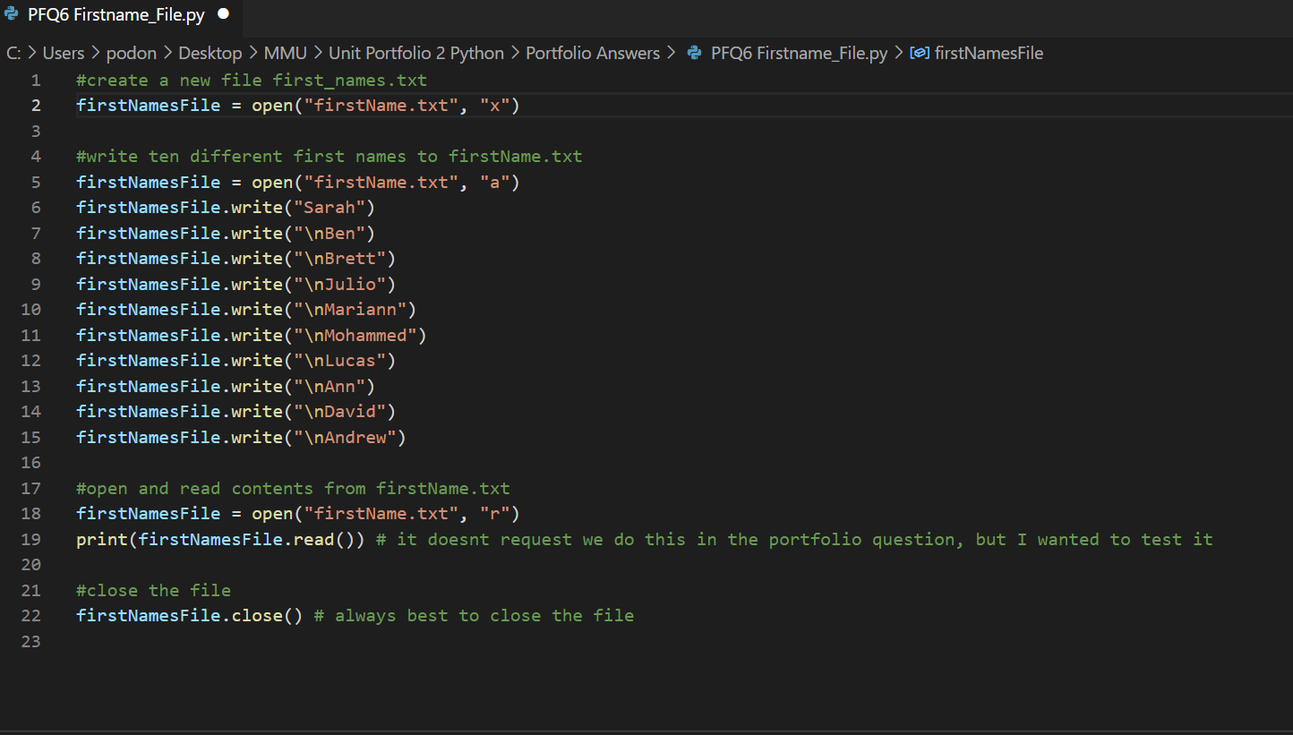

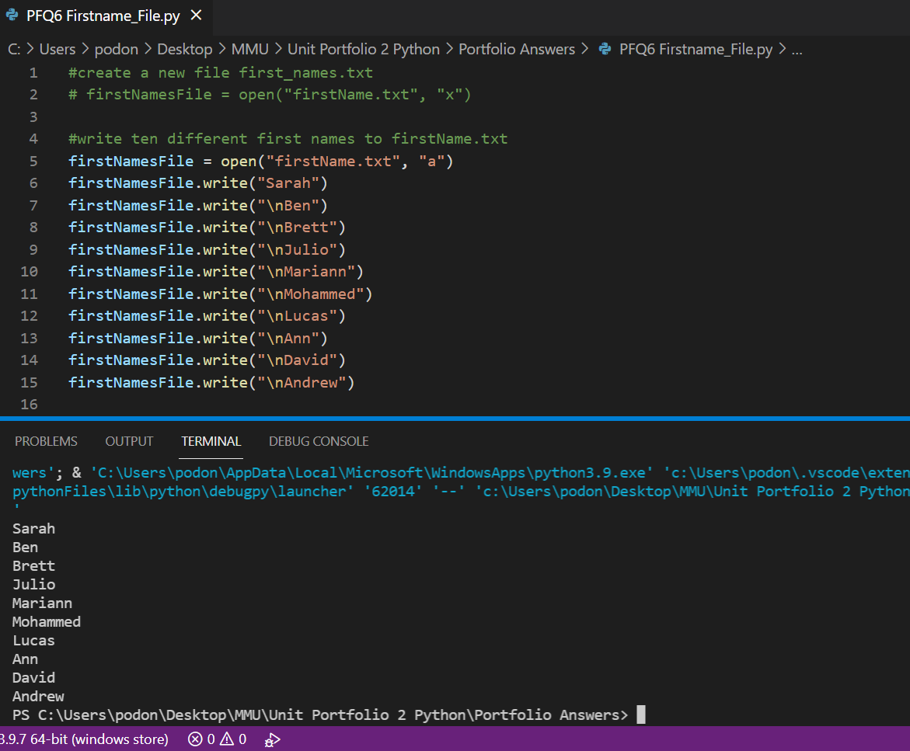

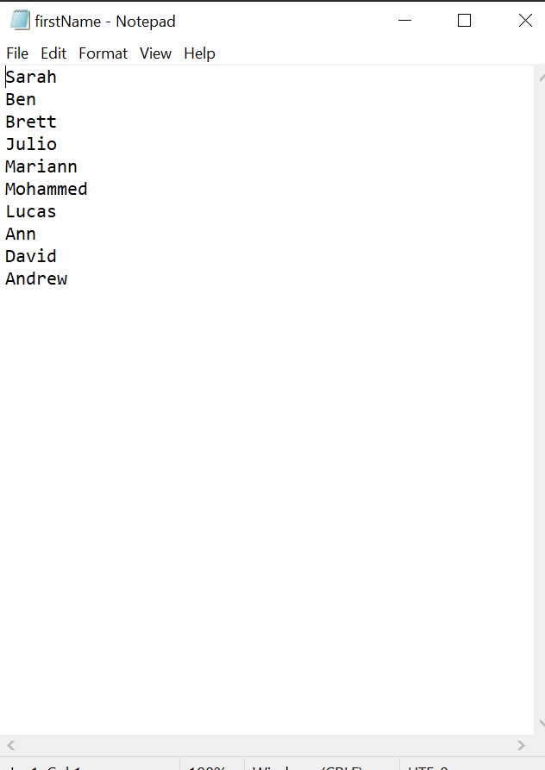

**Portfolio Question 5: Login Credentials**

Here we had to create a login screen which gives the user 3 options; register, login or exit which I coded in 3 separate functions to use when called upon by the user. I introduced a new form of data validation to my coding to make sure the user inputs an integer, by setting the users input data type to ‘float’ then ensuring that it matched the integer equivalent.

I was quite satisfied with my code, apart from for when the user selects option 3, to exit where I wanted to ask the user if they were sure and if they typed anything other than ‘yes’ I wanted the program to return to the main menu, but I couldn’t figure out how to do it. I guess that it involved a return function or a function call within a function, so that’s where I need to improve upon next time.:

**Code:**

usernames=["bjamin", "jfiddle", "kberry", "podonnell511", "mmartinez1985", "lmod2017", "am1964",]

passwords=["bjamin1234", "jfiddle1234", "kberry1234", "podonnell5111234", "mmartinez19851234", "lmod20171234", "am19641234"]

def user_choice():

print("(1) Register")

print("(2) Login")

print("(3) Exit")

def user_register():

#once successful username and pw - prompt an account successfully created message and repeat user_choice function

new_name = input("Please enter the username you wish to use:").lower()# match the case of the list items

if new_name in usernames: #check if username already exists

print("Username already exists")

user_register()#ensures username is unique

else:

usernames.append(new_name)#username is unique can can be added to the list

new_pw = input("Please enter a password (minimum 8 characters)")

while(len(new_pw) < 8): # passord has to be 8 or more characters

new_pw = input("Invalid password. Please enter a password (minimum 8 characters)")

passwords.append(new_pw) # add valid password

print("Account successfully created!")

print("Welcome to Manage My Account")

def user_login():

user_name = input("Please enter your username:").lower() # convert to lower case to match password list case policy

if user_name in usernames: #searches for matching username in the list

user_pw = input("Please enter your password:").lower() # match the case of the list

if user_pw in passwords:

print("Welcome to Manage My Account")

else:

print("Sorry the password entered does not belong to the User Name provided")

user_login() ## i wasn't sure how to bypass the username request and just ask for the password

else:

print("Invalid Username")

user_login() #repeat until a matching username is entered

def user_exit():

print("Thank you for your visit - see you next time!")

exit()

user_choice()

choice = float(input("Please enter your selection from the menu above (1-3):"))

while(choice < 1 or choice > 3 or choice != int(choice)): # data validation including to ensure input is an integer

choice = float(input("Invalid Entry - Please enter your selection from the menu above (1-3):"))

if(choice == 1):

user_register()

elif(choice == 2):

user_login()

else: #choice == 3

user_exit()







**Portfolio Question 6: First names File**

Here we created a new python file called Firstname_File and using python code, created a text file named firstName.txt, then coded to add 10 unique first names to the text file, before opening and reading the contents of the text file, then finishing by closing the file.

This is my first encounter with creating and manipulating text files using code, but I’m sure it won’t be my last! It seems reasonably straight forward and will get easier with practise.

Code:

#create a new file first_names.txt

firstNamesFile = open("firstName.txt", "x")

#write ten different first names to firstName.txt

firstNamesFile = open("firstName.txt", "a")

firstNamesFile.write("Sarah")

firstNamesFile.write("\nBen")

firstNamesFile.write("\nBrett")

firstNamesFile.write("\nJulio")

firstNamesFile.write("\nMariann")

firstNamesFile.write("\nMohammed")

firstNamesFile.write("\nLucas")

firstNamesFile.write("\nAnn")

firstNamesFile.write("\nDavid")

firstNamesFile.write("\nAndrew")

#open and read contents from firstName.txt

firstNamesFile = open("firstName.txt", "r")

print(firstNamesFile.read()) # it doesnt request we do this in the portfolio question, but I wanted to test it

#close the file

firstNamesFile.close() # always best to close the file





